Client & Dataset Selection
For this project, the selected “client” is sports analytics firm interested in understanding global performance patterns in the Olympic Games. The dataset chosen is the Olympic athlete events dataset, which contains detailed information about athletes, events, medals, demographics, and participation across all modern Olympic Games. I selected this dataset because it is rich and allows exploration of relationships between geography, climate, and athletic performance, especially in Winter Olympics.

Import my dataset, join full name of region from NOC table and classify it by climate
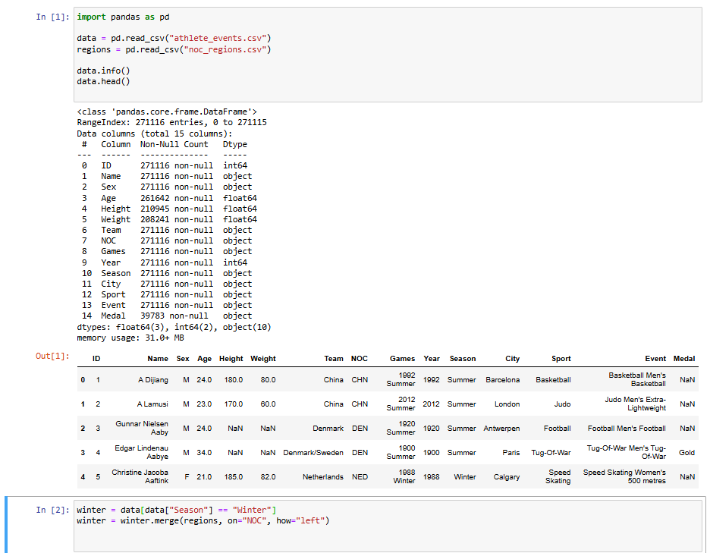

Retrieve the data from northern countries, comparing their results with warm countries per participations, medals per athlete and medals per countries
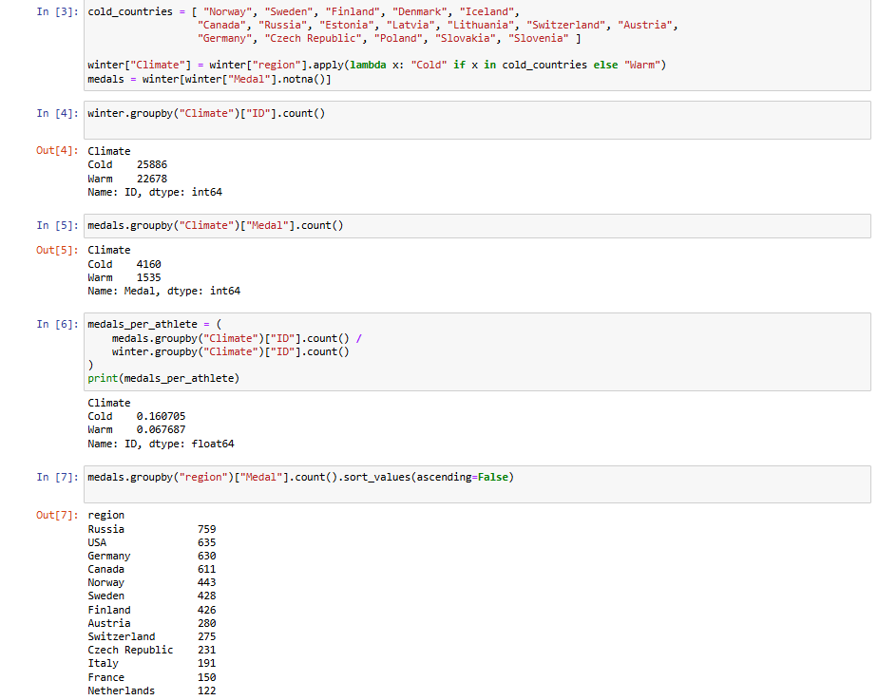
Data visualization: “Winter Olympics Participation: Cold against Warm countries”
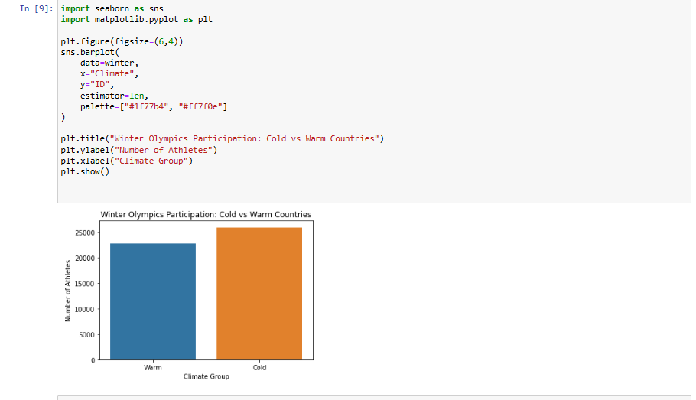
Cold countries send significantly more athletes to the Winter Olympics than warm countries.

Data visualization: “Medals per athlete: Cold against Warm countries”

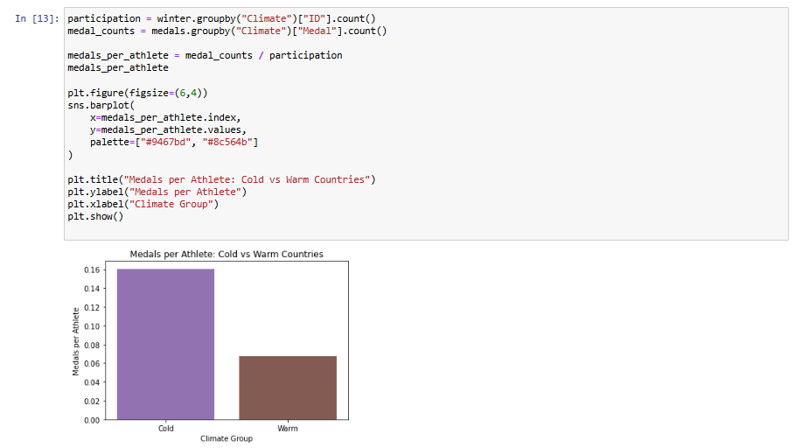
Cold countries win more medals per athlete, suggesting a better performance.
Data visualization: Medals per country
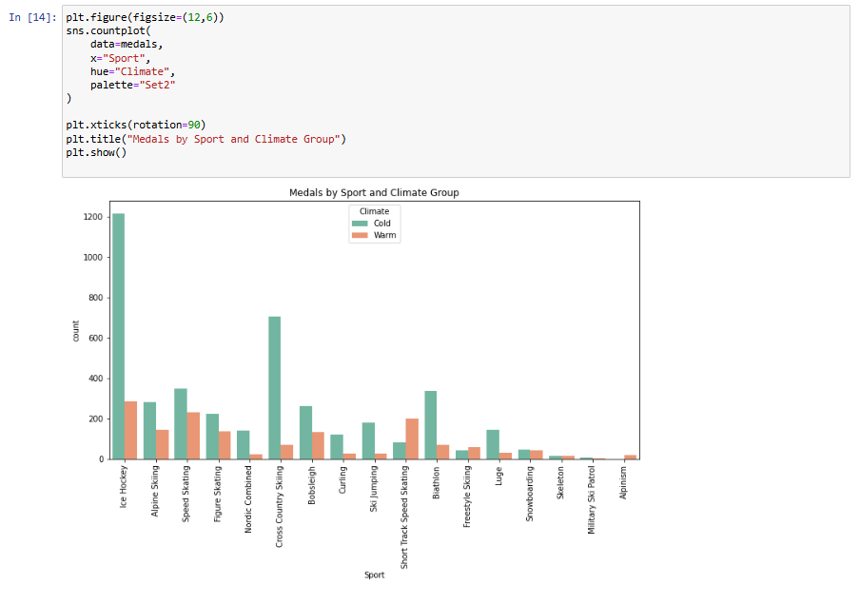
ERD
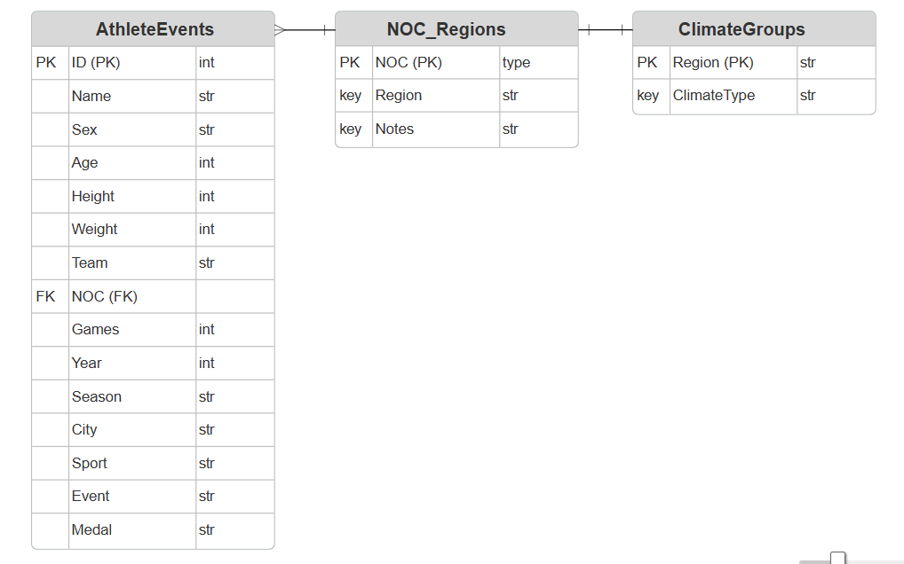

The ERD consists of three entities: AthleteEvents, NOC_Regions, and ClimateGroups. AthleteEvents stores athlete-level information for each Olympic participation. NOC_Regions maps each NOC code to its corresponding country/region. ClimateGroups assigns each region to a climate category (Cold or Warm), which is essential for testing the project hypothesis. AthleteEvents is linked to NOC_Regions through the NOC attribute, and NOC_Regions is linked to ClimateGroups through the Region attribute.

Project Description
This project explores how climate and geography influence national performance in the Winter Olympic Games, by combining athlete-level data with country-level region information, we want to determine whether athletes from colder, northern countries win more medals than those from warmer climates. The analysis will focus on participation rates, medal counts, and sport specialization patterns. This topic is relevant to sports federations, Olympic committees, and policymakers interested in understanding competitive advantages. It may also interest data-driven journalists and fans who want to uncover deeper patterns behind Olympic success. Ultimately, the project will provide evidence insights into how climate correlates with Winter Olympic outcomes.

Research Questions
- Do athletes from colder, northern countries win significantly more medals in the Winter Olympics than athletes from warmer countries?
- Is there a relationship between a country’s climate and the number of athletes it sends to Winter Olympic events?
- Which winter sports show the strongest climate-based performance differences (e.g., skiing, skating, biathlon)?

Initial Hypotheses
- Countries with colder climates will have higher Winter Olympic medal counts due to greater access to winter sports infrastructure and cultural familiarity with snow/ice sports.
- Warm-climate countries will participate less frequently in Winter Olympic events, resulting in fewer opportunities to win medals.
- Certain sports (e.g., cross-country skiing, biathlon) will show the strongest climate performance correlation, as they require natural cold environments for training.
Assumptions
The dataset accurately represents all Olympic athletes.
Missing values do not bias the climate comparison.
NOC_Region mapping is correct and consistent.

Approach
The analysis will begin by merging athlete data with regional information to classify each country into a climate group. I will first examine participation counts by country and climate type to understand main differences. Next, I will calculate medal totals and medal per athlete to compare performance fairly. I will explore relationships using correlation analysis, group comparisons, and visualizations such as bar charts. The final step will be evaluating whether the observed differences support or contradict the initial hypotheses.

SECOND MILESTONE

Summary of the descriptive statistics I looked at and WHY
For this project, I focused on several descriptive statistics to understand the differences between cold and warm climate countries in the Winter Olympics:
Participation counts - to see whether cold countries send more athletes. This helps evaluate whether climate affects opportunities to compete.
Medal totals - to compare overall success between climate groups.
Medals per athlete - a fairer metric that adjusts for participation size and shows performance efficiency.
Medals per country - to identify which countries dominate and whether warm countries have any strong performers.
Sport-specific medal counts - to see which sports show the biggest climate differences (e.g., skiing, biathlon).
These descriptive stats helped me understand the dataset before running any hypothesis tests.

Key points I discovered about the data
Here are a few important insights I found:
Cold-climate countries send more athletes to the Winter Olympics than warm countries. This already gives them more chances to win medals.
Cold-climate countries win more medals per athlete, meaning they are not only sending more athletes but also performing better on average.
Some sports show very strong climate patterns where cold countries dominate almost completely.

Testing the hypotheses.
There are some calculations already done by previous parts of the code. I will use results from it. There are bar charts below this part, which already proved all of hypotheses, here I just use statistical inference to prove it statistically.
Hypothesis First:
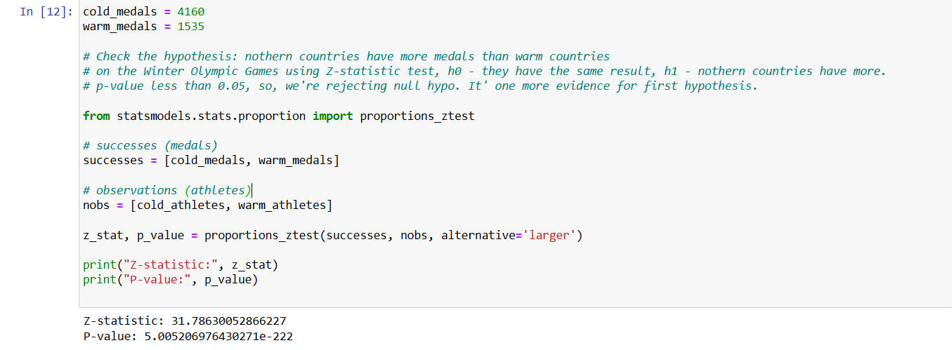Check the hypothesis: northern countries have more medals than warm countries on the Winter Olympic Games using Z-statistic test, h0 - they have the same result, h1 - northern countries have more. According to the result, p-value less than 0.05, so, we're rejecting null hypo. It' s one more evidence for first hypothesis.
Hypothesis Second:
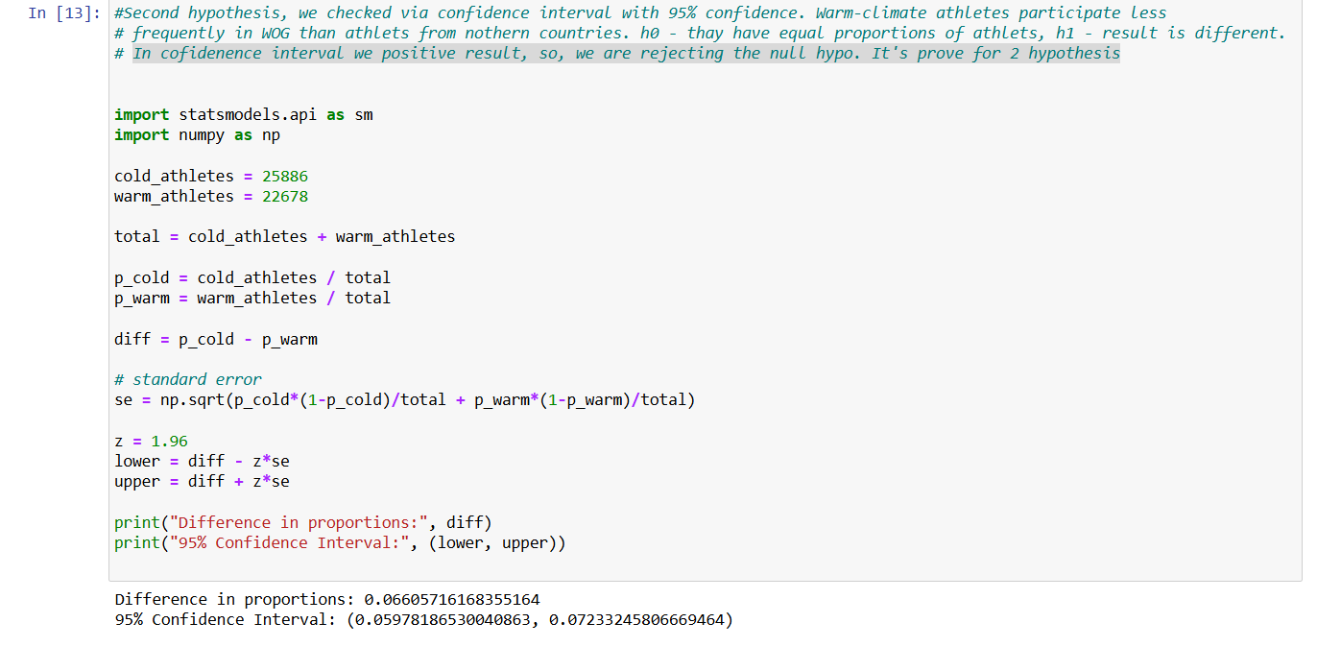
Second hypothesis we checked via confidence interval with 95% confidence. Warm-climate athletes participate less frequently in WOG than athlets from nothern countries. h0 - thay have equal proportions of athlets, h1 - result is different. In cofidenence interval we have positive result, so, we are rejecting the null hypo. It's prove for 2 hypothesis.
Hypothesis Third:
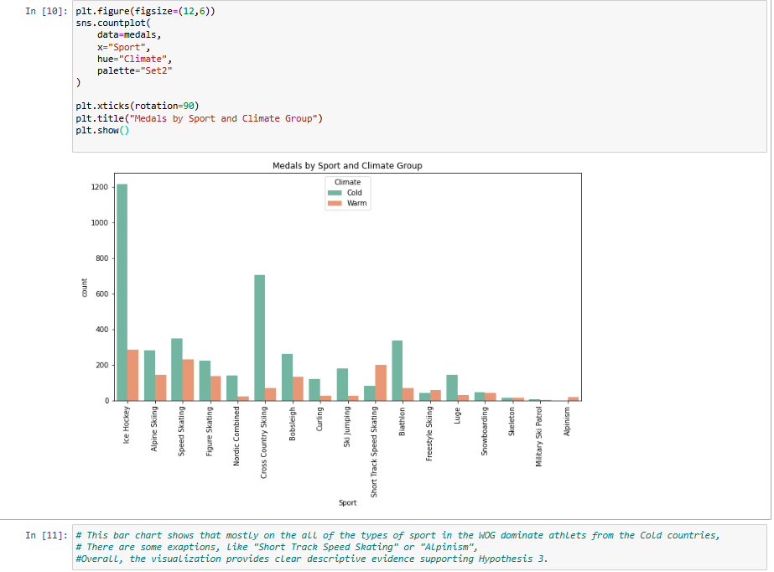

This bar chart shows that mostly on the all of the types of sport in the WOG dominate athlets from the Cold countries, there are some exaptions, like "Short Track Speed Skating" or "Alpinism", overall, the visualization provides clear descriptive evidence supporting Hypothesis 3.

Additional questions for further discussion.
For future analysis, there are a few extra questions I could look into. For example, I might check whether some countries improved over time, maybe they started participating more or got better results in certain sports. Another idea is to look at warm-climate countries that still perform really well in the Winter Olympics. The USA is a good example, since they’re technically a “warm” country in this dataset but still win a lot of medals.
I could also explore whether geography plays a role. For instance, do countries with mountains or easy access to winter sports facilities perform better, even if their overall climate is warmer? That might explain why some countries outperform others regardless of climate.

Milestone 3
Beyond descriptive statistics, I explored relationships between key variables using Pearson correlation and regression analysis. I discovered a very strong positive correlation between the number of athletes a country sends and the number of medals it wins (r = 0.90), as well as a moderate positive correlation between climate and medals per athlete (r = 0.52). To deepen the analysis, I created a new metric - medals per athlete - to measure performance efficiency. I then applied two regression models: a linear regression predicting total medal count, and a logistic regression predicting whether a country wins any medal.
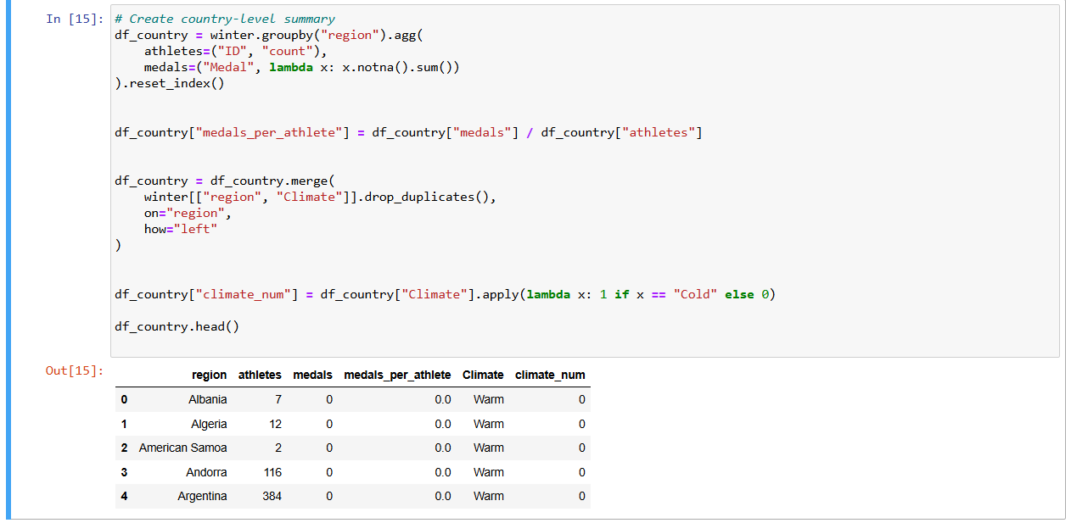
There is huge correlation between athletes and medals, what means countries that send more athletes won more medals (r = app. 0.90). This indicates that participation size is one of the strongest predictors of medal success.

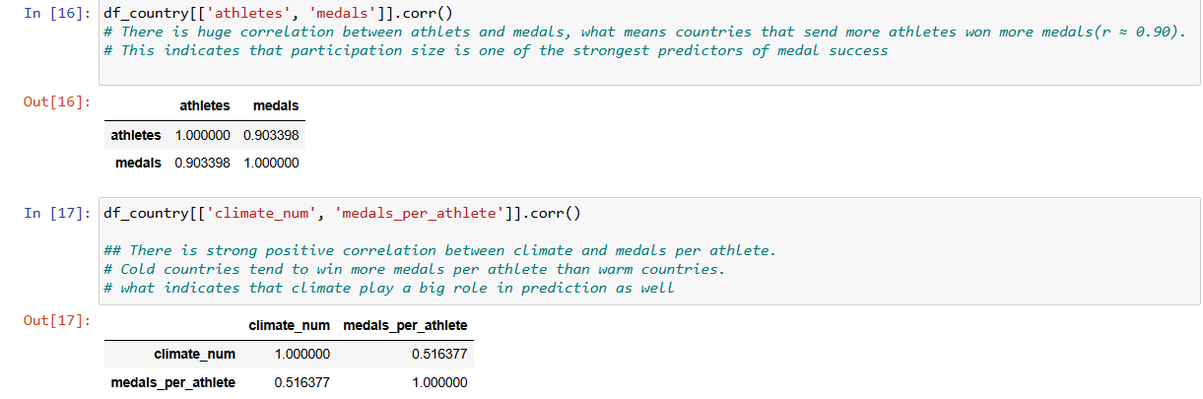
There is strong positive correlation between climate and medals per athlete. Cold countries tend to win more medals per athlete than warm countries that indicates climate play a big role in prediction as well.

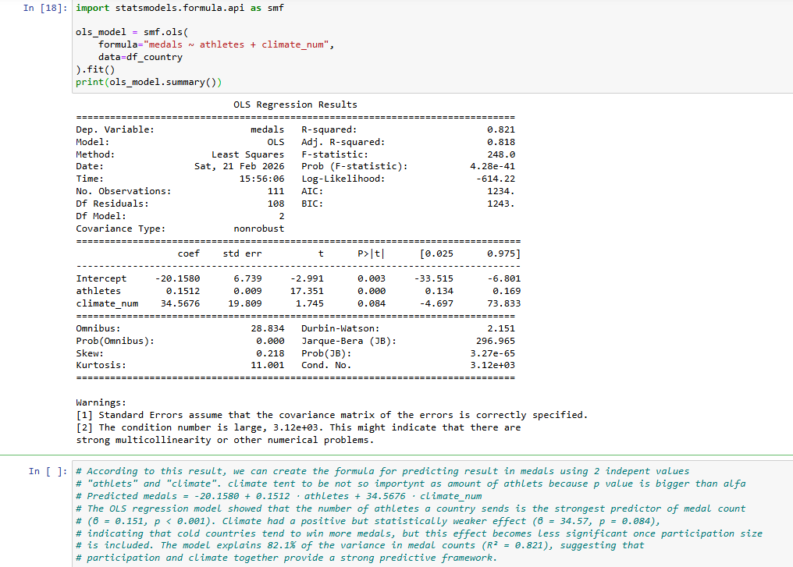
According to this result, we can create the formula for predicting result in medals using 2 independent values "athletes" and "climate". Climate tent to be not so important as number of athletes because p value is bigger than alfa. Predicted medals = -20.1580 + 0.1512 ⋅ athletes + 34.5676 ⋅ climate_num. The OLS regression model showed that the number of athletes a country sends is the strongest predictor of medal count (β = 0.151, p < 0.001). Climate had a positive but statistically weaker effect (β = 34.57, p = 0.084), indicating that cold countries tend to win more medals, but this effect becomes less significant once participation size is included. The model explains 82.1% of the variance in medal counts (R² = 0.821), suggesting that participation and climate together provide a strong predictive framework.

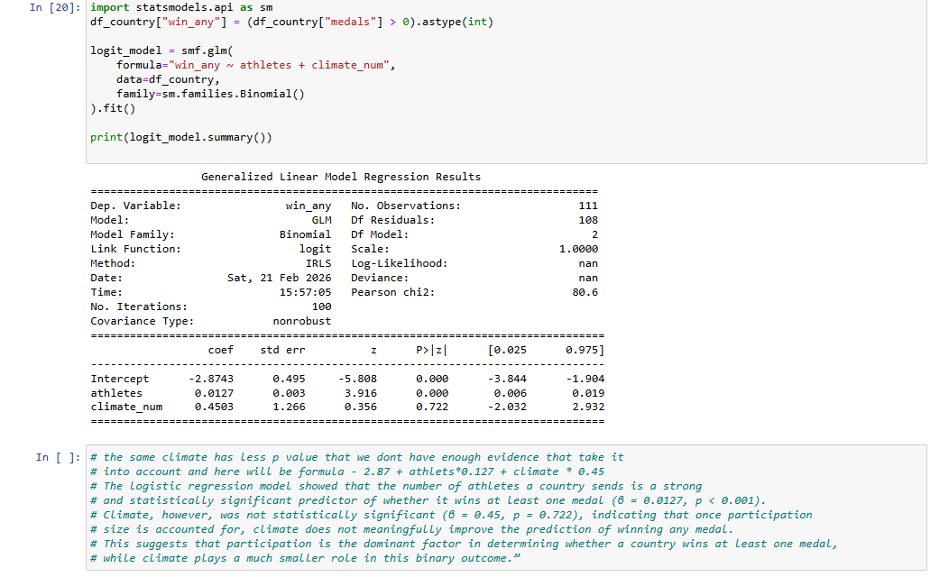
Climate has less p value that we don’t have enough evidence that take it into account. Formula - 2.87 + athlets*0.127 + climate * 0.45. The logistic regression model showed that the number of athletes a country sends is a strong and statistically significant predictor of whether it wins at least one medal (β = 0.0127, p < 0.001). Climate, however, was not statistically significant (β = 0.45, p = 0.722), indicating that once participation size is accounted for, climate does not meaningfully improve the prediction of winning any medal. This suggests that participation is the dominant factor in determining whether a country wins at least one medal, while climate plays a much smaller role in this binary outcome.”
Both models showed that participation size is the strongest predictor of medal success, while climate has a weaker or non-significant effect once participation is controlled for. These analyses provide a deeper understanding of the factors influencing Winter Olympic performance.

